opw_phantoms_wiki

Openwater has developed several phantoms for use with optical, ultrasound, and acousto-optic devices. These phantoms are designed to simulate the required characteristics of human tissue. Openwater has developed various formulations and mechanical configurations depending on the application. The phantoms were essential to establish design goals and prove system stability.

## Blood Flow System Phantoms

Phantoms used for the blood flow system are designed to simulate the optical characteristics of tissue and vasculature under investigation, most importantly scattering and absorption properties.

See page below for an overview of Openwater Blood Flow Systems.

[opw_bloodflow_gen2_hw Wiki](https://docs.google.com/document/d/1Q3LOBOVczytu94sE3Mx3TINynO3osimd-jlgie6Kn7M/edit?usp=sharing) and white paper on Gen 1 blood flow [gen1 BF White Paper.pdf](https://drive.google.com/file/d/1gqLmMxdpJQ1s7ZYlEpYmZhlL68QpFkVc/view?usp=drive_link)

Two types of phantoms are most commonly used

1. Static phantoms. These are composed of a blend of scattering and absorbing powders within a thermoset polymer. They are typically used to collect basic measurements with no motion, often for checking system performance or collecting baseline speckle contrast measurements. The amount of both the scattering and absorbing powders was iterated on to duplicate the throughput optical signal obtained from an average person’s skull.
2. Flow phantoms. These are composed of a similar block of absorptive/scattering material, in which channels are embedded for flowing fluid. This simulates blood flow at different depths beneath the surface of the tissue.

### Static Phantom Design and Manufacturing

At a high level, preparing static phantoms involves the following steps:

1. Design and fabricate the positive shape of the sensor design needed, this includes
   1. The source exit window
   2. Detector entrance windows
   3. Gaps to interrogate different tissue depths
2. Creating a negative mold in flexible polymer from the positive.
3. Preparing and pouring the scattering/absorbing polymer mixture into the mold.
4. Casting and curing the phantom in the flexible mold.
5. Finishing and polishing operations.

See the [Gen 2 Phantom Document](https://github.com/OpenwaterInternet/opw_phantoms/blob/7aa956a693cb36ca7434037c67c698c352c5c0de/optical/D0062%20-%20Gen2%20Optical%20Phantom%20Recipe.pdf) for material ratios and construction processes.

The shape of the phantom can be designed to fit the desired device under test. For example,

* See 7000-0234 and associated files in the headset phantom folder for the design of a phantom and mount for testing a complete headset. This test system will assure that all phantom batches yield the same optical characteristics of scattering and absorption.
  + 7000-0280 is a manufacturing test assembly for checking optical properties of static phantoms using an off-the-shelf continuous wave laser and photodiode detector
* See 3000-0725 for a simplified phantom disc design for testing individual sensor modules with straps

Repeatability testing has been accomplished to assure acceptable levels for measurement standard deviations. Expected Coefficient of Variation, time contrast average across scan.

CoV= stdev/average. Baseline variation expected is reported below:

| Static Phantom | 10 repeated scans, sliding module to new position on static phantom each time | 0.82% |
| --- | --- | --- |

Sensor contact, loading pressure and system geometry are essential to achieve repeatable results

### Flow Phantom Design and Manufacturing

The fundamental testing for fluid flow was accomplished with a flow phantom described in the documents referenced below. The fluid flow phantom allowed Openwater to probe both depth and speed of fluid moving below the surface of a scattering and absorbing medium.

Flow phantom preparation requires additional steps to create internal channels for fluid flow. Once the desired phantom is made with the inside channels, two tubes are affixed to each depth level needed in the design. A plate is glued to the channels so the scattering liquid can reach the closest adjacent channel. The fluid flow will transverse back and forth on each layer then exit. There is a precision liquid injection system that will move the liquid from a syringe though the phantom at a constant speed. An example of the flow system shown below:

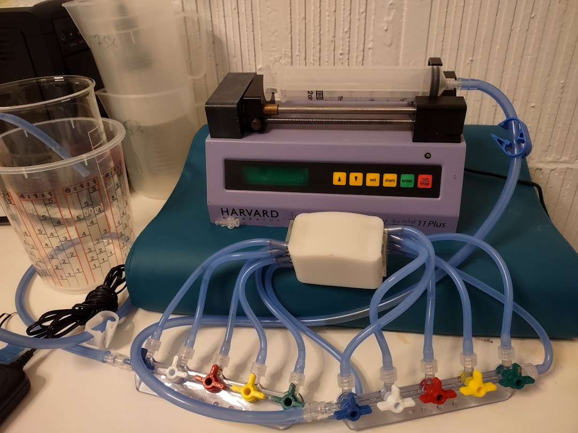

The scattering liquid formula is described below: [Phantom Construction Instructions](https://github.com/OpenwaterInternet/opw_phantoms/blob/7aa956a693cb36ca7434037c67c698c352c5c0de/ultrasound%20and%20AO/Phantom%20Construction%20Instructions.pdf).

See [Gen 2 Phantom Document](https://github.com/OpenwaterInternet/opw_phantoms/blob/7aa956a693cb36ca7434037c67c698c352c5c0de/optical/D0062%20-%20Gen2%20Optical%20Phantom%20Recipe.pdf) for detail

## Ultrasound System Phantoms

See[opw_ultrasound_wiki_draft](https://docs.google.com/document/d/1qLEyMvuXL0IMZa5vWEzOxHuGn79s_WJfsrEuW9MeZZA/edit?usp=sharing) for an overview of Openwater Ultrasound Systems. (missing Chris to add

Ultrasound phantoms are essential for evaluation of ultrasound transducer design and the tuning required to calibrate a focussing transducer system.

The following document illustrates the composition of Agarose, alcohol, and gelatin to make ultrasound phantoms; the speed of sound within the phantom matrix can be adjusted to meet the experimental criteria. [Gelatin and Agarose Phantom Making Instructions](https://github.com/OpenwaterInternet/opw_phantoms/blob/7aa956a693cb36ca7434037c67c698c352c5c0de/ultrasound%20and%20AO/Gelatin%20and%20agarose%20phantom%20making%20instructions.pdf).

IEC acoustical testing

The phantom recipe from the following two papers is recommended in the IEC standard for acoustic testing. The material may be tuned to different acoustic properties (representing different tissues):

From IEC standard for acoustical thermal testing: -reference [1]

Thermal phantom recipe for testing of HIFU beams: -reference [2]

The reference below describes a long lasting tissue phantom that can be used for acoustic and thermal testing. It is recommended for use as it was authored by FDA staff: -reference[3]

# Tissue mimicking tissue phantom for matching acoustic properties are used to evaluate safety on ultrasound therapeutic and diagnostic equipment. This is a detailed recipe that can replace the recipes found in the diagnostic and therapeutic ultrasound safety standards (IEC 60601-2-37). [Souza 2016](https://github.com/OpenwaterInternet/opw_phantoms/blob/7aa956a693cb36ca7434037c67c698c352c5c0de/ultrasound%20and%20AO/Souza_2016_J._Phys.__Conf._Ser._733_012044.pdf).

Acousto Optic Phantoms

See page [here](https://docs.google.com/document/d/1D73qPumvqMuuzOGlFXMBWwM5dg00v3ef4nRvSB1TGI4/edit) for an overview of Openwater Acousto-Optic Systems.

[Phantom Construction Instructions](https://github.com/OpenwaterInternet/opw_phantoms/blob/7aa956a693cb36ca7434037c67c698c352c5c0de/ultrasound%20and%20AO/Phantom%20Construction%20Instructions.pdf).

[4]

## References

[1] [MADSEN, EL., ZAGZEBSKI, JA. and FRANK, GR. Oil-in-gelatin dispersions for use](https://www.umbjournal.org/article/0301-5629(82)90034-5/pdf)

[as ultrasonically tissue-mimicking materials. Ultrasound in Med. & Biol., 1982, 8:](https://www.umbjournal.org/article/0301-5629(82)90034-5/pdf)

[277-287.](https://www.umbjournal.org/article/0301-5629(82)90034-5/pdf)

[2] [CHARACTERIZING AN AGAR/GELATIN PHANTOM FOR IMAGE GUIDED](https://www.umbjournal.org/article/S0301-5629(12)00582-0/fulltext)

[DOSING AND FEEDBACK CONTROL OF HIGH-INTENSITY FOCUSED ULTRASOUND](https://www.umbjournal.org/article/S0301-5629(12)00582-0/fulltext)

[3] [A tissue-mimicking material (TMM) for the acoustic and thermal characterization of high-intensity focused ultrasound (HIFU) devices](https://ieeexplore.ieee.org/abstract/document/5953995). (authored by FDA staff)

[4] [Polyvinyl chloride as a multimodal tissue-mimicking material with tuned mechanical and medical imaging properties](https://aapm.onlinelibrary.wiley.com/doi/10.1118/1.4962649)